How to Connect PHP to Databases?
PHP Application

MSSQL

MySQL

DB2

Sybase
Database Abstraction Layer (DBA, dbx, ODBC, PDO)
MySQL Extension
MSSQL Extension
IBM DB2 Extension
Sybase Extension

Connection String
- The connection string is just a combination of all the information needed to connect to a source of data.
- Key information needed for a connection:
  - Provider: type of the OLE-DB provider
  - Driver: such as Access or SQL
  - Initial File Name or Data Source: the physical database path and file name
  - DSN: name of the data source
  - Initial Catalog: the actual database name
  - User ID: the user name
  - Password: the user’ password

What connection string should we use?
Example connection string:
“Provider=Microsoft.Jet.OLEDB.4.0;Data Source=e:\\ectserver\\xfang\\Database\\movie200.mdb”
Your connection string should be like:
“Provider=Microsoft.Jet.OLEDB.4.0;Data Source=e:\\ectserver\\YOURLOGIN\\Database\\YOURDATABASEFILENAME”

Note: on your ECT account, you MUST save your database file (.mdb) under the “Database” directory. Otherwise, you cannot update the database.

How to Query Data

A simple example:
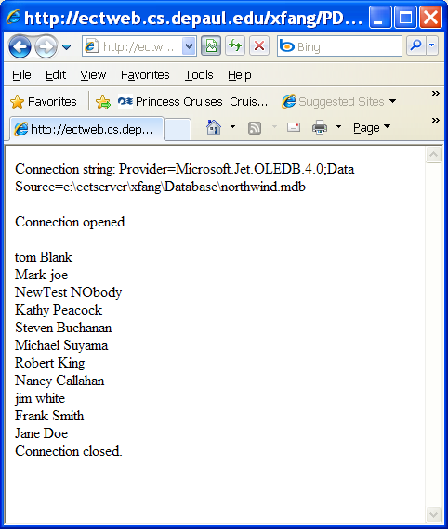 | PDO/simplequery.php  <HTML>  <BODY>  <?php  $conn = new COM("ADODB.Connection") or die("Cannot start ADO");  $connString= "Provider=Microsoft.Jet.OLEDB.4.0;Data Source=e:\\ectserver\\xfang\\Database\\northwind.mdb";  //creates the connection object and define the connection string  print "Connection string: $connString<p>";  $conn->Open($connString);  $rs = $conn->Execute("SELECT FirstName, LastName FROM Employees");  //opens a recordset from the connection object  print "Connection opened.<p>";  while (!$rs->EOF) {  //keep looping until end of file  ?>  <div>  <?php  $fv1=$rs->Fields("FirstName");  $fv2=$rs->Fields("LastName");  print "$fv1&nbsp";  print "$fv2<br>";  $rs->MoveNext();  }  $rs->Close();  print "Connection closed."  ?>  </div>  </Body>  </HTML>

Using Parameters with Queries

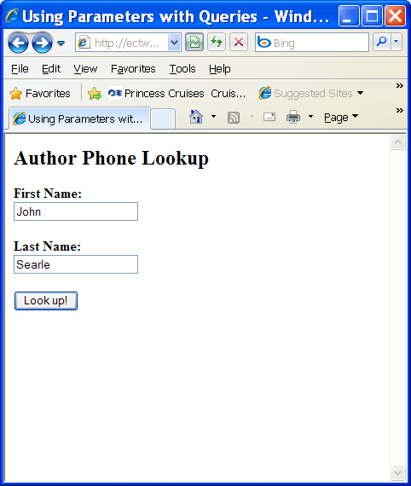  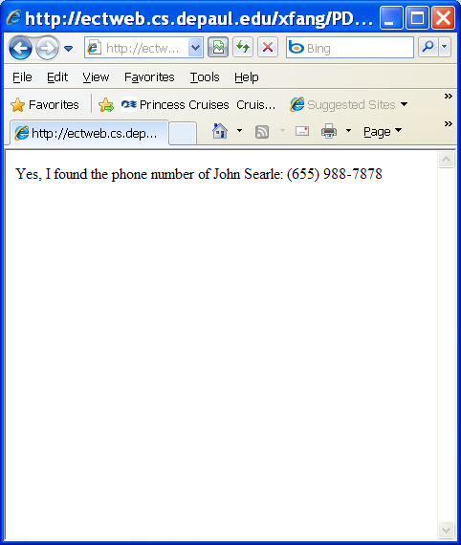 | PDO/queryparameter.html  <html>  <head><title>Using Parameters with Queries</title></head>  <body>  <form action="queryparameter.php" method="post">  <h2>Author Phone Lookup</h2>  <b>First Name:</b>  <br>  <input type="text" name="txtFirstname">  <p>  <b>Last Name:</b>  <br>  <input type="text" name="txtLastname">  <p>  <input type="submit" value="Look up!">  </form>  </body>  </html>  PDO/queryparameter.php  <html>  <body>  <?php  $firstName=filter_input(INPUT_POST, "txtFirstname");  $lastName=filter_input(INPUT_POST, "txtLastname");  $conn = new COM("ADODB.Connection") or die("Cannot start ADO");  $connString= "Provider=Microsoft.Jet.OLEDB.4.0;Data Source=e:\\ectserver\\xfang\\Database\\Authors.mdb";  //creates the connection object and define the connection string  $conn->Open($connString);  $selectCommand="SELECT phone FROM Authors WHERE au_fname='".$firstName."' AND au_lname='".$lastName."'";  $rs = $conn->Execute($selectCommand);  //opens a recordset from the connection object  if (!$rs->EOF){  $phone=$rs->Fields("phone");  print "Yes, I found the phone number of $firstName $lastName: $phone";  }  else  print "Sorry, I cannot find this person's phone.";  $rs->Close;  ?>  </body>  </html>

Building a Contact Management System
Adding Contacts
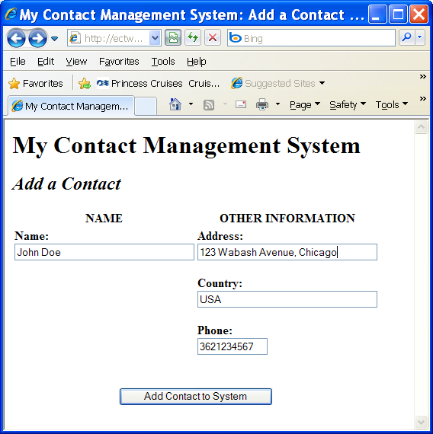  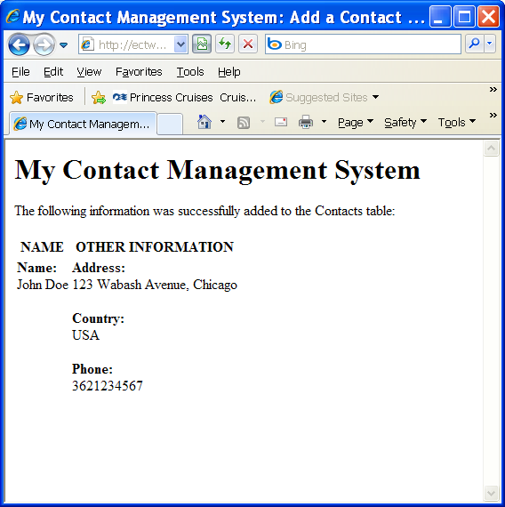 | PDO/addcontact.html  <HTML>  <HEAD>  <TITLE>My Contact Management System: Add a Contact</TITLE>  </HEAD>  <BODY>  <h1>My Contact Management System</h1>  <h2><em>Add a Contact</em></h2>  <FORM METHOD="post" ACTION="addcontact.php">  <table cellspacing=2 cellpadding=1>  <tr>  <th>NAME</th>  <th>OTHER INFORMATION</th>  </tr>  <tr>  <td valign=top>  <P><STRONG>Name:</STRONG><BR>  <INPUT TYPE="text" NAME="CName" SIZE=35 MAXLENGTH=75></P>  </td>  <td valign=top>  <P><STRONG>Address:</STRONG><BR>  <INPUT TYPE="text" NAME="CAddress" SIZE=35 MAXLENGTH=100></P>  <P><STRONG>Country:</STRONG><BR>  <INPUT TYPE="text" NAME="Country" SIZE=35 MAXLENGTH=35></P>  <P><STRONG>Phone:</STRONG><BR>  <INPUT TYPE="text" NAME="Phone" SIZE=11 MAXLENGTH=11></P>  </td>  </tr>  <tr>  <td align=center colspan=2><br><br>  <INPUT TYPE="SUBMIT" NAME="submit" VALUE="Add Contact to System">  </TD>  </TR>  </TABLE>  </FORM>  </BODY>  </HTML>  PDO/addcontact.php  <html>  <HEAD>  <TITLE>My Contact Management System: Add a Contact</TITLE>  </HEAD>  <body>  <?php  $Name=$_POST["CName"];  $Address=$_POST["CAddress"];  $Country=$_POST["Country"];  $Phone=$_POST["Phone"];  $conn = new COM("ADODB.Connection") or die("Cannot start ADO");  $connString= "Provider=Microsoft.Jet.OLEDB.4.0;Data Source=e:\\ectserver\\xfang\\Database\\Authors.mdb";  //creates the connection object and define the connection string  $conn->Open($connString);  $rs=$conn->Execute("SELECT ContactID FROM Contacts ORDER BY ContactID DESC");  $ID=$rs->Fields("ContactID")+1;  $insertCommand="INSERT INTO Contacts (ContactID,ContactName,Address,Country,Phone) VALUES ($ID,'$Name','$Address','$Country','$Phone');";  $rs=$conn->Execute($insertCommand);  ?>  <h1>My Contact Management System</h1>  <p>The following information was successfully added to the Contacts table:<p>  <table cellspacing=2 cellpadding=1>  <tr>  <th>NAME</th>  <th>OTHER INFORMATION</th>  </tr>  <tr>  <td valign=top>  <P><STRONG>Name:</STRONG><BR>  <?php  print "$Name";  ?>  </td>  <td valign=top>  <P><STRONG>Address:</STRONG><BR>  <?php  print "$Address";  ?></P>  <P><STRONG>Country:</STRONG><BR>  <?php  print "$Country";  ?></P>  <P><STRONG>Phone:</STRONG><BR>  <?php  print "$Phone";  ?>  </td>  </tr>  </TABLE>  </body>  </html>

Updating Contacts
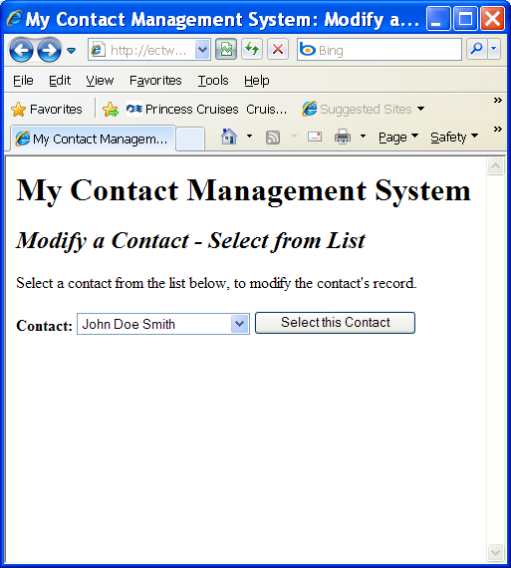  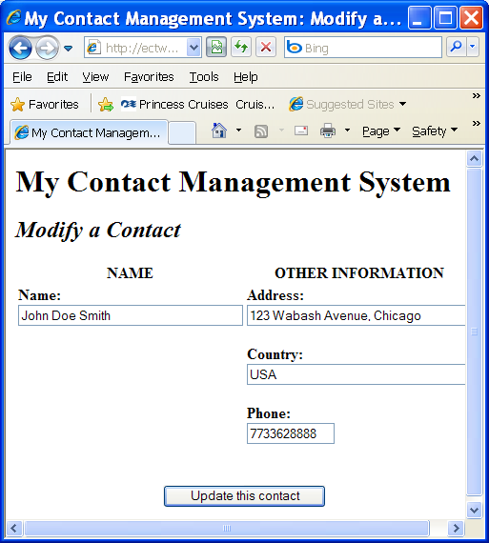  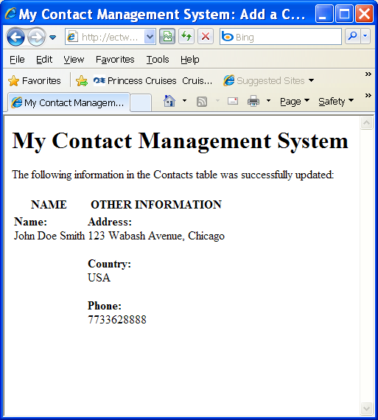 | PDO/recordselection.php  <HTML>  <HEAD>  <TITLE>My Contact Management System: Modify a Contact</TITLE>  </HEAD>  <BODY>  <h1>My Contact Management System</h1>  <h2><em>Modify a Contact - Select from List</em></h2>  <P>Select a contact from the list below, to modify the contact's  record.</P>  <form action="recordedit.php" method="post">  <P><strong>Contact:</strong>  <select name="myid">  <?php  $conn = new COM("ADODB.Connection") or die("Cannot start ADO");  $connString= "Provider=Microsoft.Jet.OLEDB.4.0;Data Source=e:\\ectserver\\xfang\\Database\\Authors.mdb";  //creates the connection object and define the connection string  $conn->Open($connString);  $rs=$conn->Execute("SELECT ContactID,ContactName FROM Contacts;");  while (!$rs->EOF)  {  $ContactID=$rs->Fields("ContactID");  $ContactName=$rs->Fields("ContactName");  print "<option value=\"$ContactID\">$ContactName</option>";  $rs->MoveNext();  }  $rs->Close();  ?>  </select>  <INPUT TYPE="SUBMIT" NAME="submit" VALUE="Select this Contact"></P>  </form>  </BODY>  </HTML>  PDO/recordedit.php  <HTML>  <HEAD>  <TITLE>My Contact Management System: Modify a Contact</TITLE>  </HEAD>  <BODY>  <h1>My Contact Management System</h1>  <h2><em>Modify a Contact</em></h2>  <?php  $conn = new COM("ADODB.Connection") or die("Cannot start ADO");  $connString= "Provider=Microsoft.Jet.OLEDB.4.0;Data Source=e:\\ectserver\\xfang\\Database\\Authors.mdb";  //creates the connection object and define the connection string  $conn->Open($connString);  $ID=$_POST["myid"];  $rs=$conn->Execute("SELECT ContactID,ContactName,Address,Country,Phone FROM Contacts WHERE ContactID=$ID;");  if (!$rs->EOF)  {  $ContactID=$rs->Fields("ContactID");  $ContactName=$rs->Fields("ContactName");  $Address=$rs->Fields("Address");  $Country=$rs->Fields("Country");  $Phone=$rs->Fields("Phone");  ?>  <FORM METHOD="POST" ACTION="modifycontact.php">  <table cellspacing=2 cellpadding=1>  <tr>  <th>NAME</th>  <th>OTHER INFORMATION</th>  </tr>  <tr>  <td valign=top>  <INPUT TYPE="hidden" Name="CID" Value='  <?php  print "$ContactID";  ?>'>  <P><STRONG>Name:</STRONG><BR>  <INPUT TYPE="text" NAME="CName" Value='  <?php  print "$ContactName";  ?>'  SIZE=35 MAXLENGTH=75></P>  </td>  <td valign=top>  <P><STRONG>Address:</STRONG><BR>  <INPUT TYPE="text" NAME="CAddress" Value='  <?php  print "$Address";  ?>'  SIZE=35 MAXLENGTH=100></P>  <P><STRONG>Country:</STRONG><BR>  <INPUT TYPE="text" NAME="Country" Value='  <?php  print "$Country";  ?>'  SIZE=35 MAXLENGTH=35></P>  <P><STRONG>Phone:</STRONG><BR>  <INPUT TYPE="text" NAME="Phone" Value='  <?php  print "$Phone";  }  $rs->Close();  ?>'  SIZE=11 MAXLENGTH=11></P>  </td>  </tr>  <tr>  <td align=center colspan=2><br><br>  <INPUT TYPE="SUBMIT" NAME="submit" VALUE="Update this contact">  </TD>  </TR>  </TABLE>  </FORM>  </BODY>  </HTML>  PDO/modifycontact.php  <html>  <HEAD>  <TITLE>My Contact Management System: Add a Contact</TITLE>  </HEAD>  <body>  <?php  $ID=$_POST["CID"];  $Name=$_POST["CName"];  $Address=$_POST["CAddress"];  $Country=$_POST["Country"];  $Phone=$_POST["Phone"];  $conn = new COM("ADODB.Connection") or die("Cannot start ADO");  $connString= "Provider=Microsoft.Jet.OLEDB.4.0;Data Source=e:\\ectserver\\xfang\\Database\\Authors.mdb";  //creates the connection object and define the connection string  $conn->Open($connString);  $updateCommand="UPDATE Contacts SET ContactName='$Name',Address='$Address',Country='$Country',Phone='$Phone' WHERE ContactID=$ID;";  $rs=$conn->Execute($updateCommand);  ?>  <h1>My Contact Management System</h1>  <p>The following information in the Contacts table was successfully updated:<p>  <table cellspacing=2 cellpadding=1>  <tr>  <th>NAME</th>  <th>OTHER INFORMATION</th>  </tr>  <tr>  <td valign=top>  <P><STRONG>Name:</STRONG><BR>  <?php  print "$Name";  ?>  </td>  <td valign=top>  <P><STRONG>Address:</STRONG><BR>  <?php  print "$Address";  ?></P>  <P><STRONG>Country:</STRONG><BR>  <?php  print "$Country";  ?></P>  <P><STRONG>Phone:</STRONG><BR>  <?php  print "$Phone";  ?>  </td>  </tr>  </TABLE>  </body>  </html>

Deleting Contacts
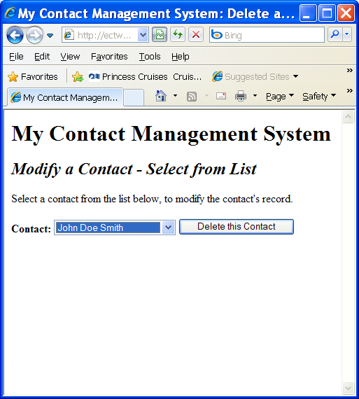  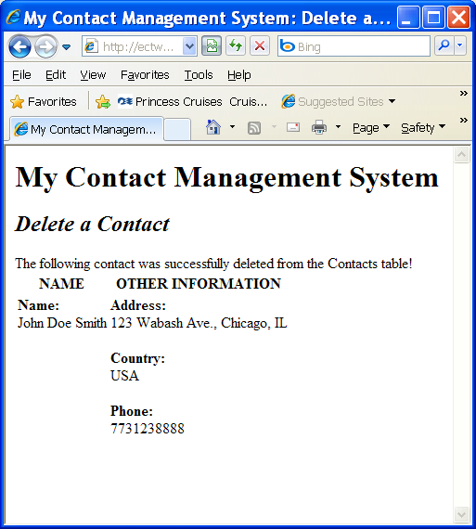 | PDO/deleteselection.php  <HTML>  <HEAD>  <TITLE>My Contact Management System: Delete a Contact</TITLE>  </HEAD>  <BODY>  <h1>My Contact Management System</h1>  <h2><em>Modify a Contact - Select from List</em></h2>  <P>Select a contact from the list below, to modify the contact's  record.</P>  <form action="deletecontact.php" method="post">  <P><strong>Contact:</strong>  <select name="myid">  <?php  $conn = new COM("ADODB.Connection") or die("Cannot start ADO");  $connString= "Provider=Microsoft.Jet.OLEDB.4.0;Data Source=e:\\ectserver\\xfang\\Database\\Authors.mdb";  //creates the connection object and define the connection string  $conn->Open($connString);  $rs=$conn->Execute("SELECT ContactID,ContactName FROM Contacts;");  while (!$rs->EOF)  {  $ContactID=$rs->Fields("ContactID");  $ContactName=$rs->Fields("ContactName");  print "<option value=\"$ContactID\">$ContactName</option>";  $rs->MoveNext();  }  $rs->Close();  ?>  </select>  <INPUT TYPE="SUBMIT" NAME="submit" VALUE="Delete this Contact"></P>  </form>  </BODY>  </HTML>  PDO/deletecontact.php  <HTML>  <HEAD>  <TITLE>My Contact Management System: Delete a Contact</TITLE>  </HEAD>  <BODY>  <h1>My Contact Management System</h1>  <h2><em>Delete a Contact</em></h2>  <?php  $conn = new COM("ADODB.Connection") or die("Cannot start ADO");  $connString= "Provider=Microsoft.Jet.OLEDB.4.0;Data Source=e:\\ectserver\\xfang\\Database\\Authors.mdb";  //creates the connection object and define the connection string  $conn->Open($connString);  $ID=$_POST["myid"];  $rs=$conn->Execute("SELECT ContactID,ContactName,Address,Country,Phone FROM Contacts WHERE ContactID=$ID;");  if (!$rs->EOF)  {  $ContactID=$rs->Fields("ContactID");  $ContactName=$rs->Fields("ContactName");  $Address=$rs->Fields("Address");  $Country=$rs->Fields("Country");  $Phone=$rs->Fields("Phone");  ?>  <p>The following contact was successfully deleted from the Contacts table!  <table cellspacing=2 cellpadding=1>  <tr>  <th>NAME</th>  <th>OTHER INFORMATION</th>  </tr>  <tr>  <td valign=top>  <P><STRONG>Name:</STRONG><BR>  <?php  print "$ContactName";  ?></td>  <td valign=top>  <P><STRONG>Address:</STRONG><BR>  <?php  print "$Address";  ?>  <P><STRONG>Country:</STRONG><BR>  <?php  print "$Country";  ?>  <P><STRONG>Phone:</STRONG><BR>  <?php  print "$Phone";  }  $rs->Close();  $rs2=$conn->Execute("DELETE FROM Contacts WHERE ContactID=$ID;");  ?>  </td>  </tr>  </TABLE>  </FORM>  </BODY>  </HTML>

